|  |  |
| --- | --- |
| **Module title:** | **Data mining and text analytics With application in SAS** |
| **Student number (id)** | 6897234 |
| **Assessment title:** | **Individual Assignment - Exploring Road Traffic Accident Data and Text Analytics Insights** |

**Task 1** – Data Exploration and Cleaning **[20 marks]**

To show your skills in data exploration, visualization, summary statistics generation, and data cleaning.

The dataset contains detailed records of road accidents in Surrey, UK, during 2021, covering aspects like severity, road conditions, weather influences, and involved parties. It forms the basis for exploring accident patterns, predicting severity using machine learning, and analyzing related text data for actionable insights.

**Exploratory Data Analysis**

**Table 1**

The exploratory data analysis revealed the following insights:

**Structure of the Dataset**:  
The dataset comprises 2,480 rows and 35 columns, detailing road accidents in Surrey, UK, during 2021. It includes numerical, categorical, and temporal variables.

**Key Variables**:

* Longitude and latitude: Geographical location.
* Accident severity: Severity level.
* Number of vehicles involved.
* Number of casualties.
* Weather conditions: At the time of the accident.

**Missing Data**:  
Variables such as longitude, latitude, accident severity, number of vehicles, and number of casualties each have one missing value. The **Describe Missing Values** feature in SAS Viya confirmed these patterns.

**Data Quality**:  
The dataset is mostly complete, with minimal missing data. Temporal variables like time and date require format checks, and categorical variables may need cleaning to address inconsistencies.

**Summary Statistics**

The dataset's summary statistics, generated in SAS Viya, included central tendencies (mean, median, mode) and dispersion (standard deviation, range). These statistics revealed insights into variables such as accident severity, number of casualties, and vehicles involved. Mean and standard deviation clarified data distribution while identifying potential outliers and inconsistencies.

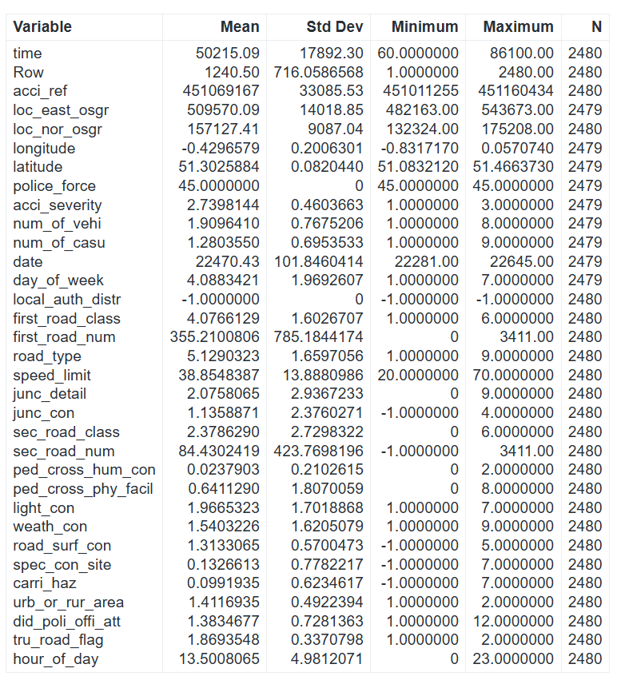

**Table 2**

**Data Visualization**

The visualizations analyze factors influencing road accidents in Surrey in 2021, focusing on variables like accident severity, time, environmental conditions, and road characteristics. They uncover patterns, identify risk factors, and highlight areas for targeted interventions.

**Distribution of Accident Severity:**

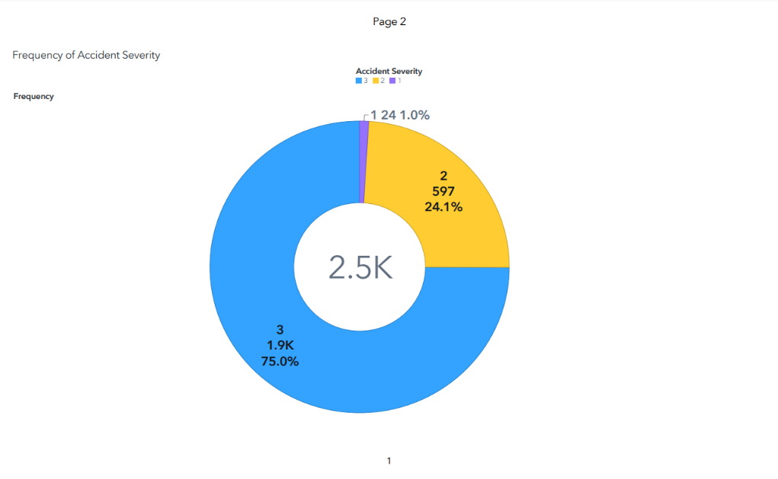

Image 1

The pie chart highlights the imbalance in the target variable, Accident Severity, which includes three levels:

1. **Severity Level 3 (Low Severity)**: Majority class, accounting for 75% of the data.
2. **Severity Level 2 (Medium Severity)**: Represents 24.1% of records.
3. **Severity Level 1 (High Severity)**: Rarest class, making up only 1%.

This imbalance poses a challenge for predictive modelling, potentially biasing predictions toward the majority class. Techniques like oversampling or class-weighted algorithms may be necessary to improve performance on rare, high-severity cases.

**Frequency of Accidents by Hour of the Day:**

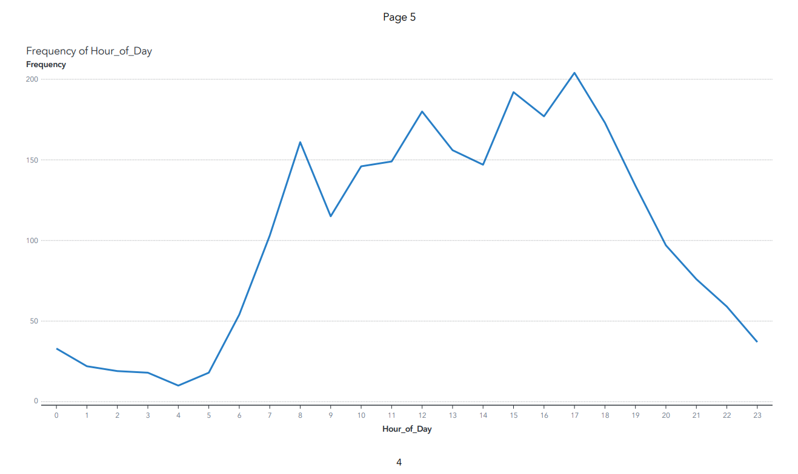

Image 2

The line graph shows the distribution of accidents across a 24-hour period:

* **Peak Hours**: Accidents spike during morning (8-9 AM) and evening (4-6 PM) rush hours due to increased traffic congestion.
* **Off-Peak Hours**: Accident frequency drops significantly between midnight and early morning (10 PM-6 AM) when traffic volume is lower.
* **Trend**: Higher accident frequency aligns with times of increased commuter activity.

This visualization highlights temporal patterns, emphasizing the need for targeted traffic management and safety measures during peak hours.

**Accident Frequency by Junction Type:**

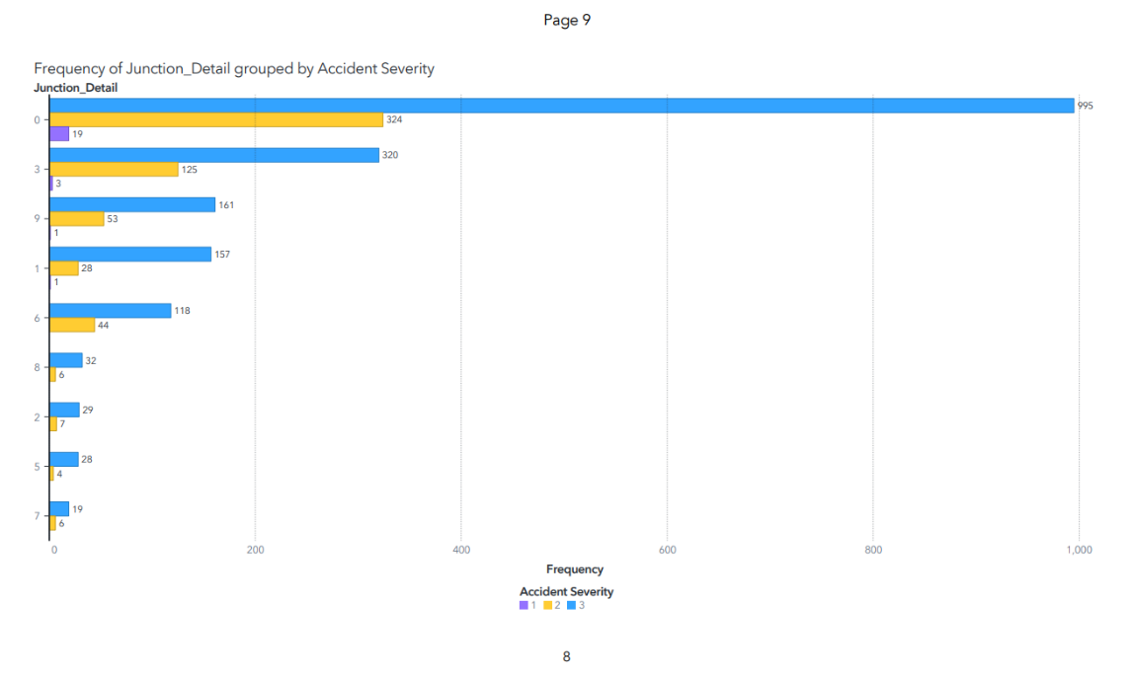

**Image 4**

The graph shows the distribution of accidents by severity (1: Fatal, 2: Serious, 3: Slight) across junction types. Non-junction areas (“0”) have the highest number of accidents, mainly slight, followed by serious and fatal. T or staggered junctions (“3”) are the second highest, primarily contributing to slight accidents. This highlights non-junction areas as major hotspots, with T or staggered junctions also playing a notable role in lower-severity accidents.

**Frequency of Accidents by Road Type:**

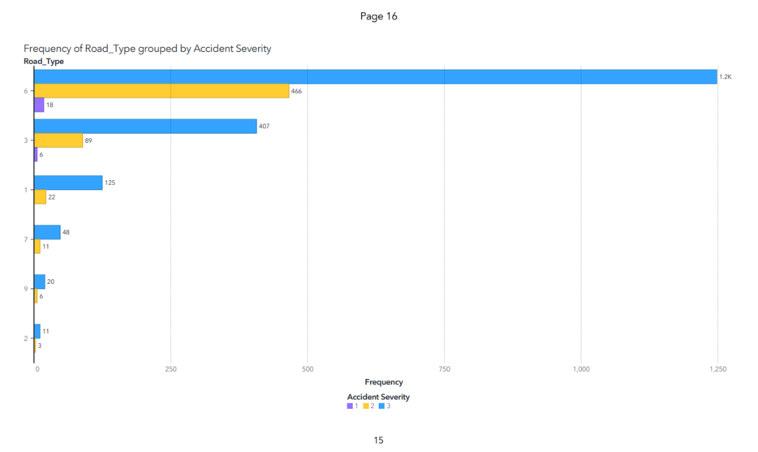

**Image 3**

The graph depicts accident frequency by severity (1: Fatal, 2: Serious, 3: Slight) across road types. Single carriageways have the highest number of accidents, primarily slight, followed by serious and fatal. Dual carriageways rank second, contributing significantly, while roundabouts have the lowest frequency and no fatal accidents, likely due to their safer design. This highlights single carriageways as major hotspots, with dual carriageways also notable and roundabouts relatively safer.

**Frequency of Accidents by Speed Limit:**

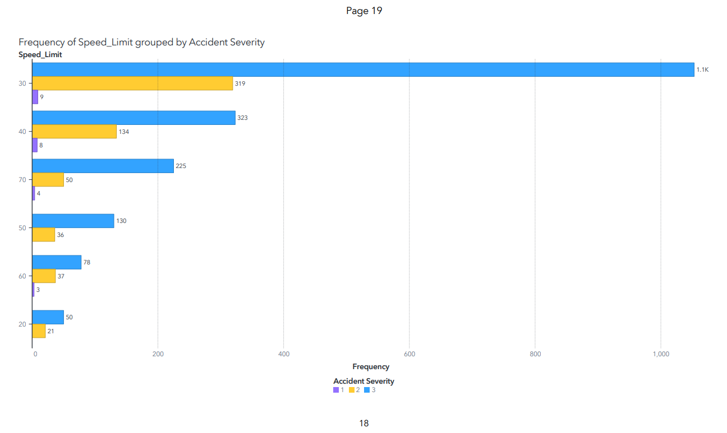

**Image 5**

The graph displays accident frequency by severity (1: Fatal, 2: Serious, 3: Slight) across speed limits. Most accidents occur in 30 mph zones, mainly slight, followed by serious and fatal, reflecting urban traffic patterns. While 40 mph and 70 mph zones see fewer accidents, they show significant serious and slight proportions. Higher-speed zones generally have fewer accidents but a greater risk of severe outcomes, emphasizing the dangers of high-speed travel.

**Frequency by Number of Casualties:**

**Image 6**

The graph shows that accidents with a single casualty are most frequent, predominantly slight in severity. Accidents with multiple casualties are less common, with higher severity levels observed as the number of casualties increases. This highlights the link between casualty count and accident severity.

**Frequeny by Urban/Rural:**

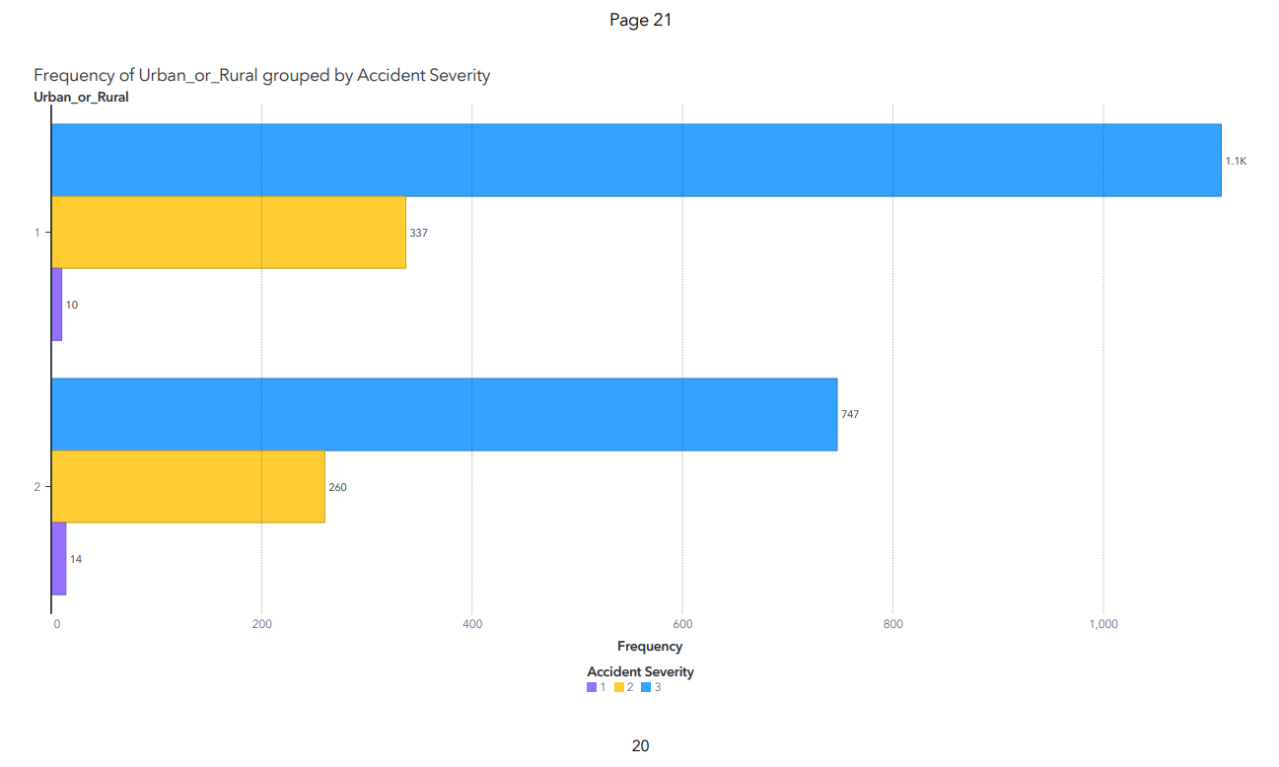

**Image 7**

The graph illustrates the frequency of road accidents by severity (1: Fatal, 2: Serious, 3: Slight) in urban and rural areas. Urban areas have a higher number of accidents, predominantly slight, while rural areas, despite fewer accidents, show a higher proportion of fatal incidents. This indicates that rural accidents are generally more severe compared to urban ones.

**Accident Frequency by Weather Condition:**

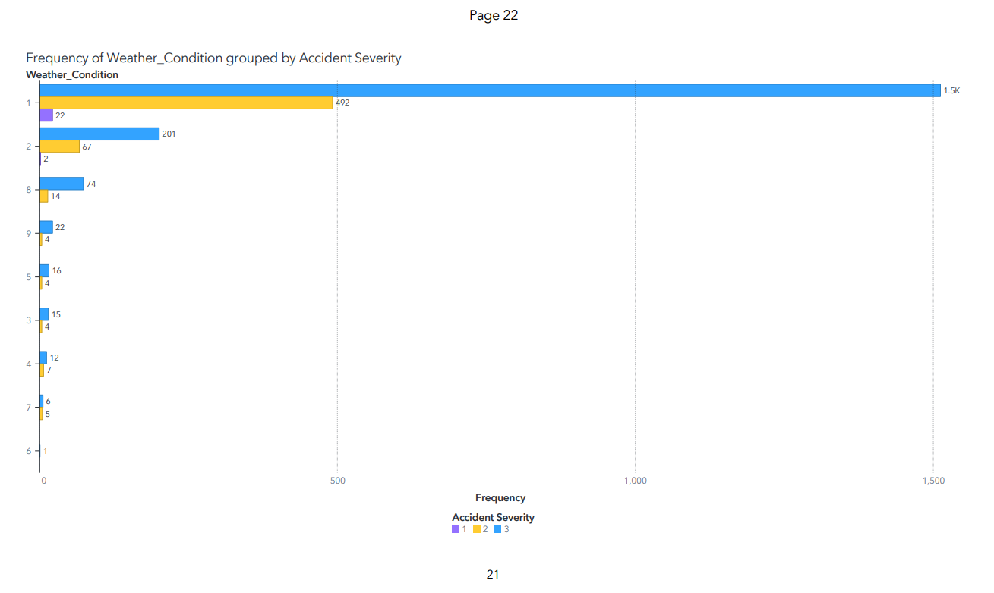

**Image 8**

The graph displays the frequency of accidents by severity (1: Fatal, 2: Serious, 3: Slight) across weather conditions. Most accidents occur in fine weather, dominated by slight accidents, followed by serious and fatal. Light rain also contributes significantly, primarily to slight and serious accidents. While fine weather sees the highest accident frequency due to greater traffic volume, weather conditions do not strongly influence accident severity.

**Accident Severity Distribution across Surrey:**

**Image 9**

The map visualizes the geographical distribution of accidents across Surrey, with severity levels (1: Fatal, 2: Serious, 3: Slight) labeled for each point. The color of the points indicates the number of casualties involved, while the size of the circles represents the number of vehicles involved. This provides a clear spatial understanding of accident hotspots and their severity, along with the impact in terms of vehicles and casualties involved.

**Data Cleaning:**

The data cleaning process resolved missing values and inconsistencies, ensuring readiness for analysis. Missing values in Accident Severity and other columns (e.g., longitude, latitude, Number of Vehicles, and Number of Casualties) were addressed using SAS Viya’s “Replace Missing Values” feature via code and flows. Numerical variables were imputed with the median, and categorical variables with the mode. This process produced a complete and consistent dataset, ready for predictive modelling and analysis.

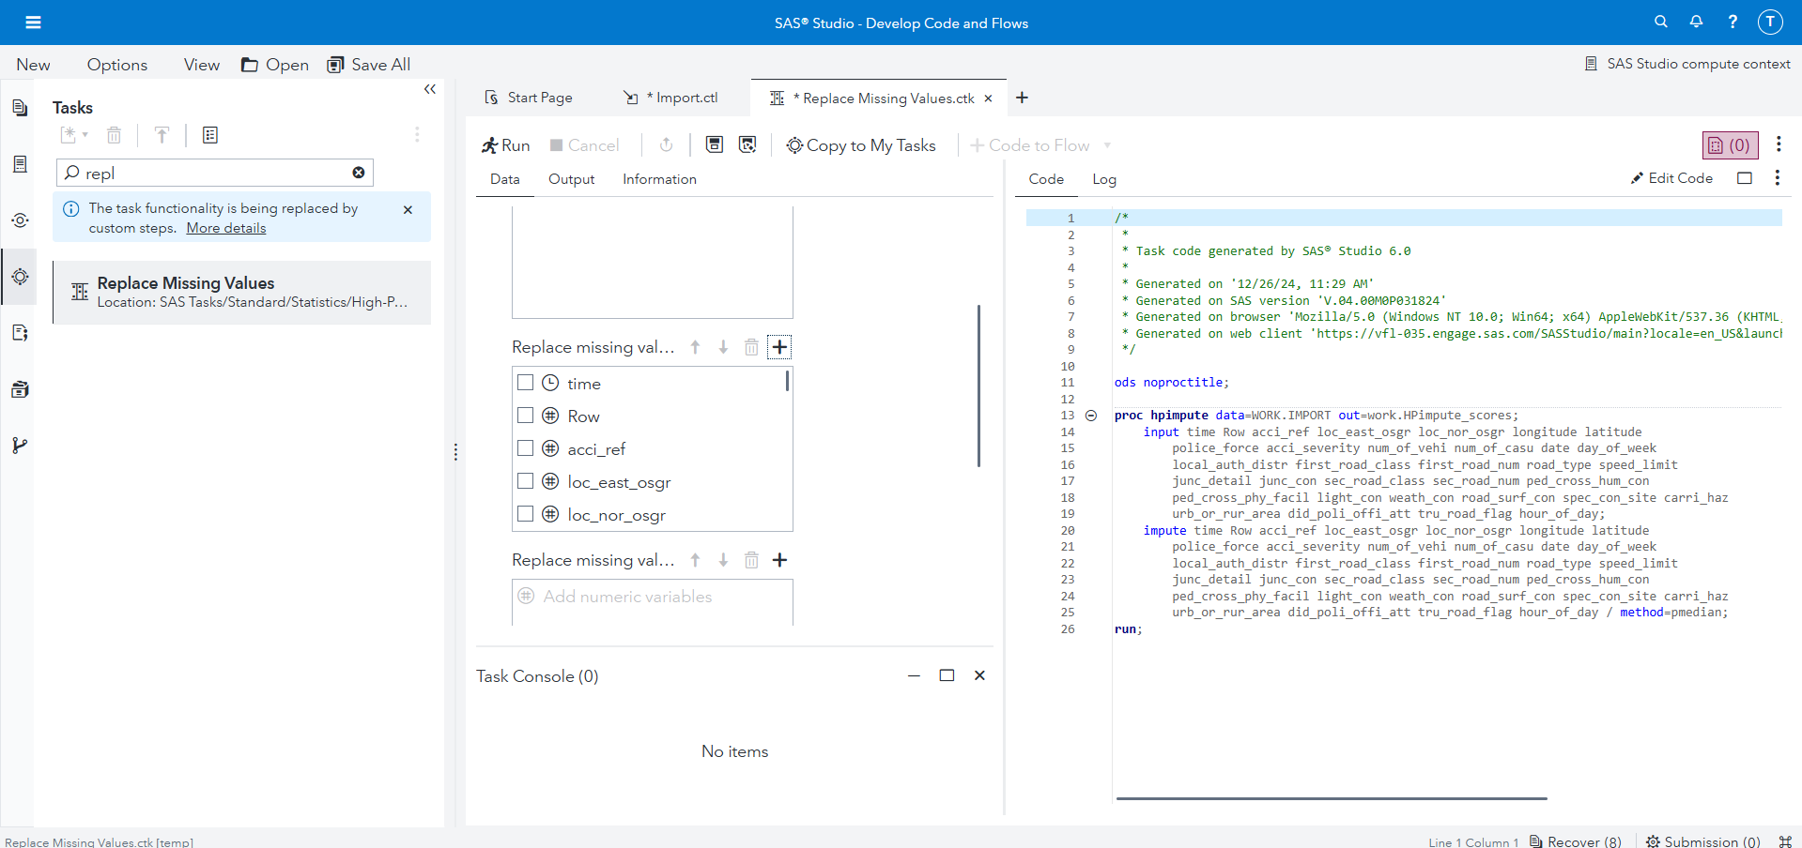

**Image 10**

The successful execution of the "Replace Missing Values" task in SAS Viya, as shown in the accompanying screenshot, was followed by a detailed output table summarizing the imputed values and their respective imputation methods. This thorough cleaning process ensures the dataset is complete and retains the reliability essential for accurate predictive modeling.

**Table 3**

**Task 2** – Predicting Accident Severity **[30 marks]**

You will apply machine learning techniques to predict accident severity using the dataset

The goal of this task is to develop machine learning models to predict accident severity based on the provided dataset.

**Data Balancing**

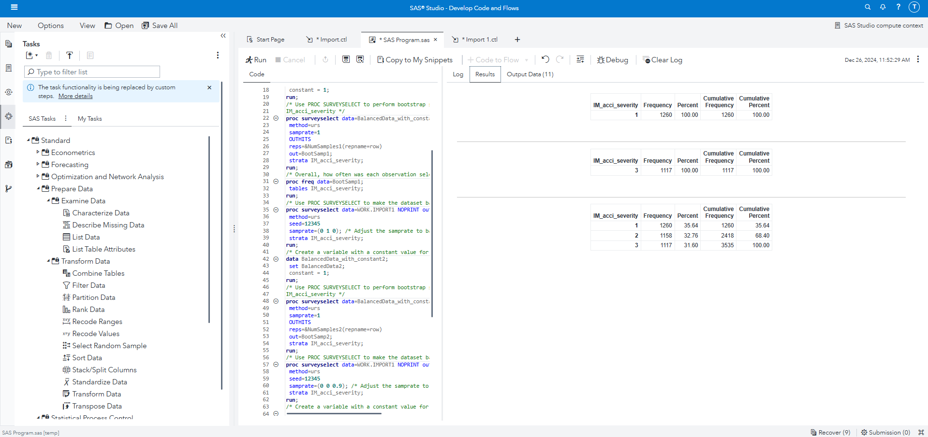

**Image 11**

Given the significant imbalance in the target variable, with fatal accidents comprising only 1% of the data, the professor-provided SAS code was used to balance the dataset after imputing missing values. This ensured a fair representation of all classes in the target variable. Using the balanced dataset, multiple predictive models were built and evaluated to identify the most effective approach for classifying accident severity and understanding the key factors influencing severe outcomes.

**Machine Learning Pipeline**

**Image12**

This SAS pipeline outlines the machine learning workflow for predicting accident severity using the balanced dataset. The process starts with input data containing pre-processed and balanced data, followed by training three supervised learning models: Logistic Regression and Decision Tree.

**Feature Selection**

Feature selection was performed using variable importance scores from the Decision Tree model. This method measures each variable's contribution to splitting nodes and improving model performance. High-priority features like the hour of the day and Local Authority District were identified as the most strongly associated with accident severity.

This approach ensures the inclusion of only the most relevant features, reducing complexity, enhancing interpretability, and minimizing overfitting. As a result, the model is better equipped to generalize to unseen data while maintaining accuracy and efficiency.

The variable importance chart ranks features based on their impact on predicting accident severity. The most influential variables include hour of the day, Local Authority District, junction details, and first road number. Other features, such as longitude, number of casualties, and weather conditions, contribute significantly but with relatively lower importance. These insights underline the relationship between these variables and accident severity, aiding in model refinement.

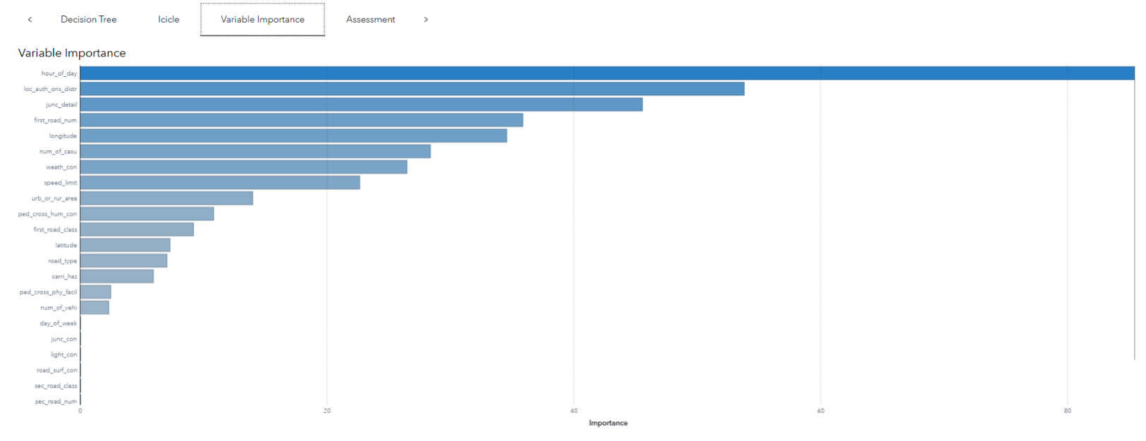

**Image 13**

**Logistic Regression:**

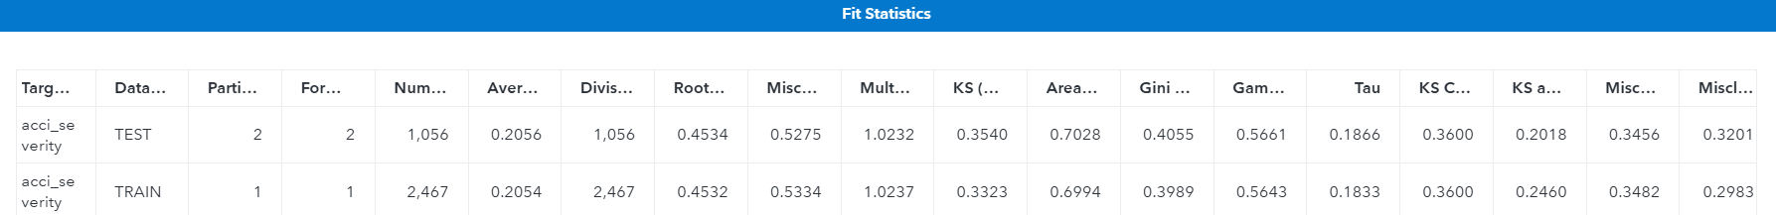

**Image 14**

The logistic regression model was evaluated on training and testing datasets, yielding the following observations:

1. **Model Performance Metrics**:

* The AUC was 0.6994 (training) and 0.7028 (testing), indicating moderate discriminatory power.
* Misclassification rates of 53.34% (training) and 52.75% (testing) highlight challenges in predicting severity, particularly for minority classes like fatal accidents.
* KS statistic values of 0.3323 (training) and 0.3540 (testing) show reasonable separation between predicted probabilities and actual classes.
* A lift value of 1.023 demonstrates limited ability to prioritize severe cases effectively.

1. **Confusion Matrix Insights**:  
   The model performs well for the dominant class (slight accidents) but struggles with less frequent classes (serious and fatal accidents), reflected in high false negative rates for minority classes.
2. **Strengths**:

* **Consistency**: Similar metrics across training and testing datasets indicate good generalization.
* **Interpretability**: Provides clear insights into predictors of accident severity.
* **Baseline Performance**: Serves as a foundation for comparing advanced models.

1. **Weaknesses**:

* **Class Imbalance**: Struggles with minority classes, reducing recall and precision for severe accidents.
* **High Misclassification**: Over 50% misclassification highlights difficulty in accurate predictions.
* **Limited Predictive Power**: Moderate KS and lift values indicate room for improvement.

This analysis highlights the model's strengths as a baseline and its limitations, particularly in addressing class imbalance and predictive power for severe cases.

**5.Variable Importance:**

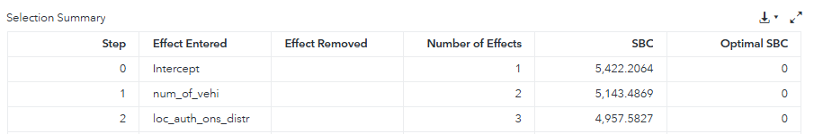

**Table 4**

The stepwise logistic regression analysis identified two key predictors of accident severity:

1. **Number of Vehicles Involved**:  
   This was the most influential feature, strongly associated with greater severity due to the increased likelihood of multiple casualties or more severe outcomes.
2. **Local Authority District**:  
   This feature highlights geographical differences in severity, driven by variations in road conditions, traffic density, and enforcement of traffic regulations across districts.

These variables significantly improve the model's ability to distinguish severity levels, emphasizing their importance in predictive analysis.

**Conclusion:**The logistic regression model serves as a baseline for predicting accident severity but is limited by class imbalance and its reliance on linear assumptions. To improve performance, advanced models like Random Forests or Gradient Boosting should be considered. Rebalancing techniques, such as oversampling or under sampling, are also recommended to enhance recall and precision for severe accident classes.

**Decision Trees:**

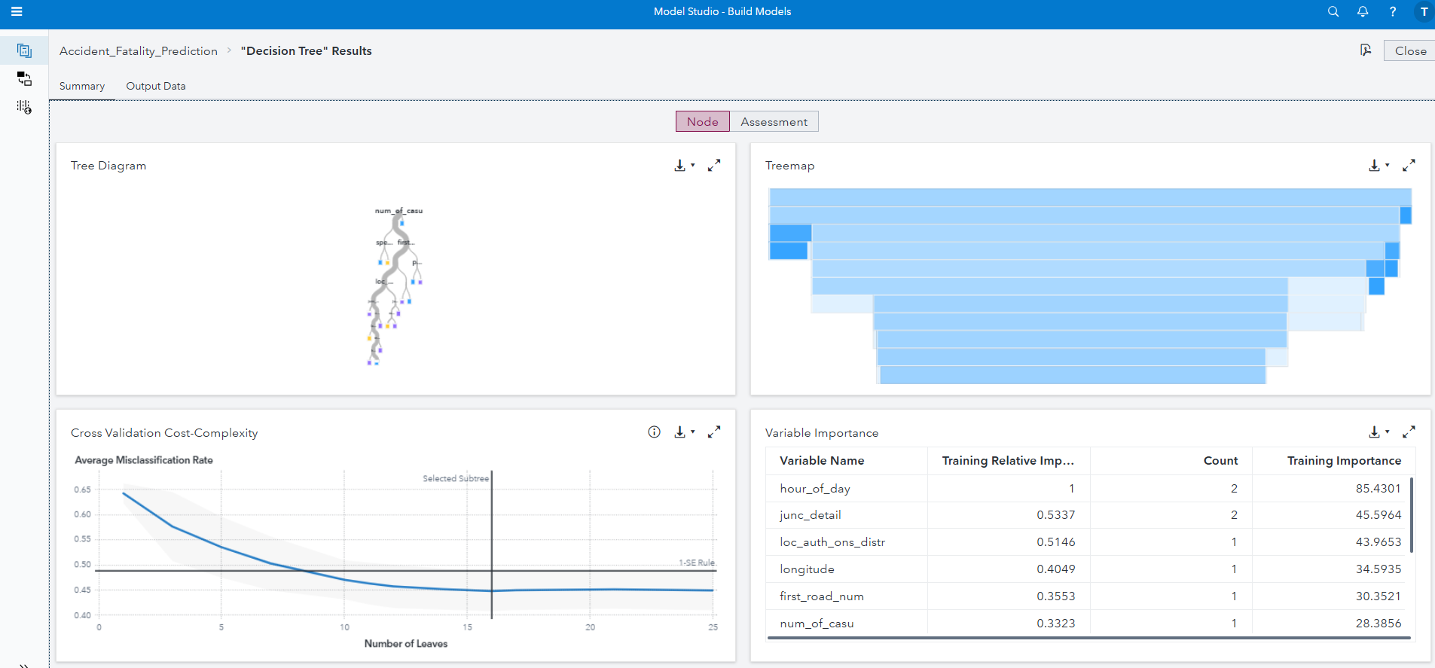

**Image 15**

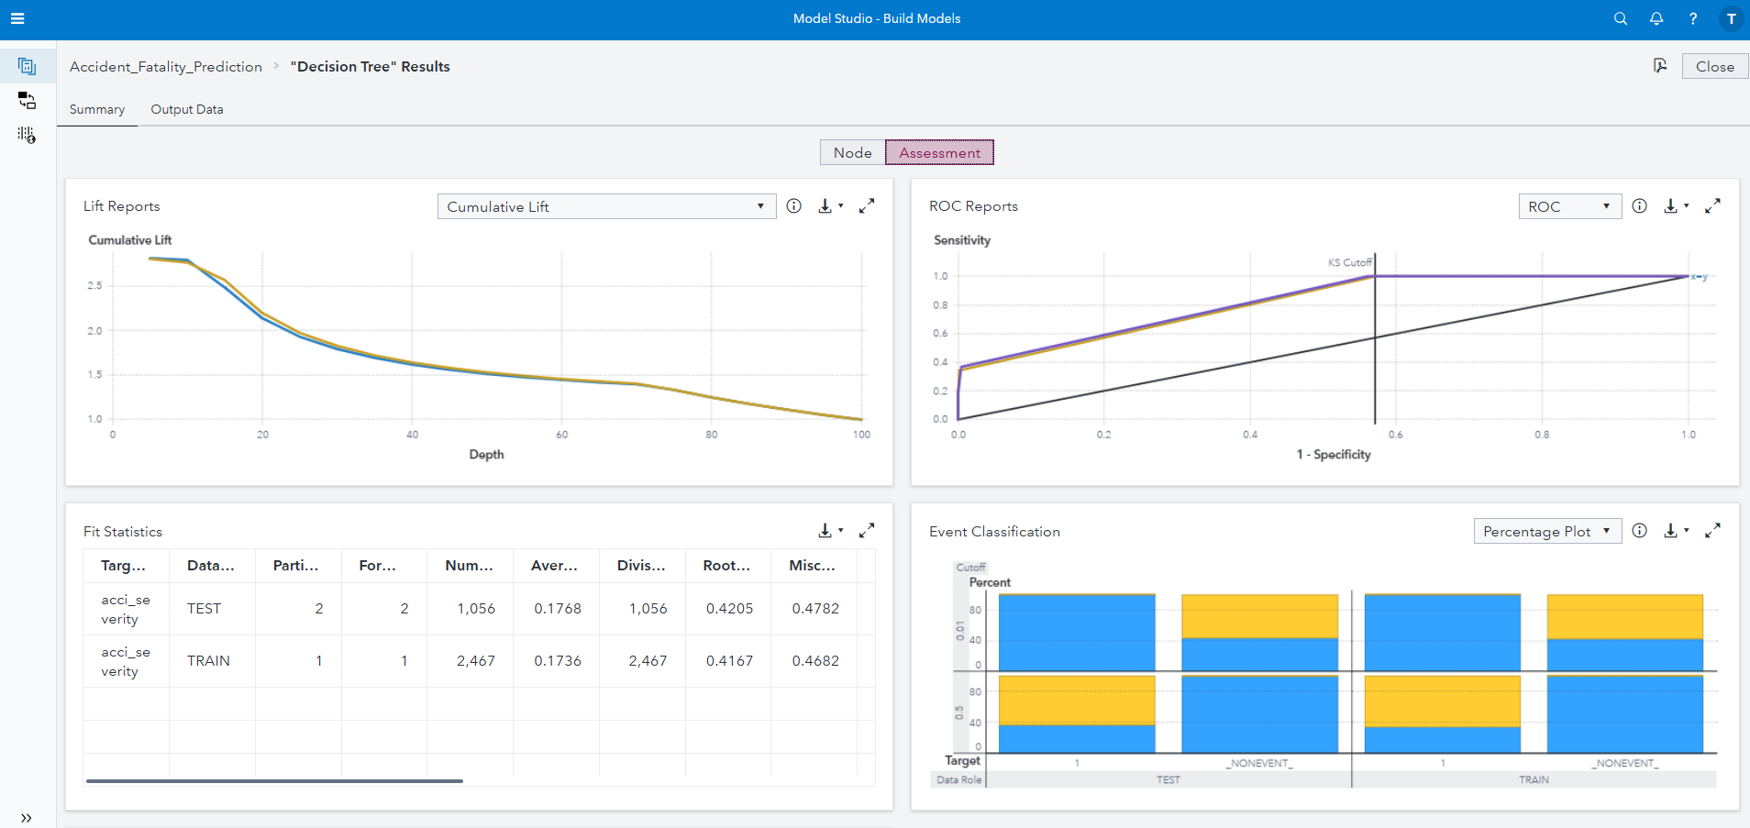

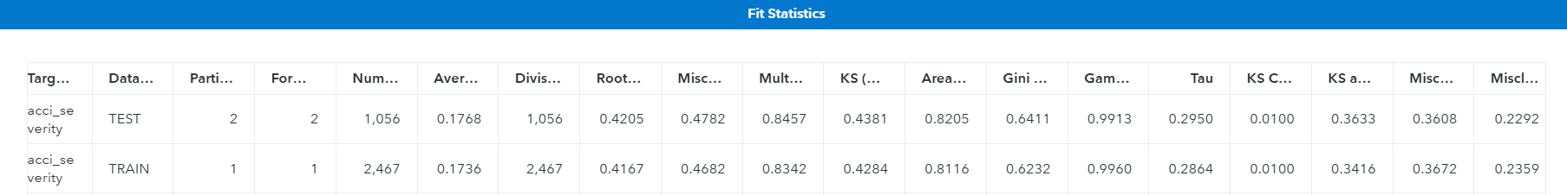

**Image 16**

The decision tree model was evaluated using training and testing datasets, with the following observations:

1. **Model Performance Metrics**:

* Achieved an AUC of 0.8116 (training) and 0.8205 (testing), showing better discriminatory power than logistic regression.
* Misclassification rates of 46.82% (training) and 47.82% (testing) indicate improved accuracy but challenges in predicting minority classes persist.
* KS statistic values (0.4284 training, 0.4381 testing) highlight stronger separation of predicted probabilities.
* Lift value of 0.8457 demonstrates the model’s ability to prioritize severe cases, though improvements are needed.

1. **Confusion Matrix Insights:**  
   The model predicts slight accidents well but struggles with serious and fatal accidents. Improved handling of minority classes is evident compared to logistic regression due to a lower misclassification rate.
2. **Strengths**:

* **Non-Linear Relationships**: Effectively captures interactions and improves accuracy.
* **Feature Prioritization**: Identifies critical predictors for targeted interventions.
* **Interpretability**: Tree visualization aids understanding of decision-making.
* **Improved Accuracy**: Outperforms logistic regression in misclassification rates and AUC.

1. **Weaknesses**:

* **Class Imbalance**: Struggles with accurate predictions for minority classes.
* **Overfitting Risk**: Prone to overfitting despite good generalization.
* **Complexity**: Large trees may hinder interpretation and implementation.

1. **Variable Importance**:  
   Key predictors include:

* **Number of Casualties**: Strong correlation with accident severity.
* **Hour of the Day**: Higher severity at nighttime or early morning.
* **Speed Limit**: Severe accidents increase with higher speed limits.
* **Local Authority District**: Reflects geographic variations in road conditions.
* **Junction Details and Road Type**: Influence severity based on accident location.

**Conclusion**:  
The decision tree model outperforms logistic regression, effectively capturing non-linear relationships and prioritizing key features. While class imbalance and tree complexity remain challenges, ensemble methods like Random Forests or Gradient Boosting and rebalancing techniques can further improve performance.

**Recommendations for Improving Road Safety:**

Based on the analysis of accident severity predictors and model results, the following recommendations are proposed:

1. **Implement Time-Sensitive Interventions**
   * **Peak Hour Monitoring**: Increase traffic enforcement during critical peak hours to reduce accident frequency.
   * **Dynamic Traffic Management**: Leverage real-time traffic data to optimize signal timings and manage congestion effectively during high-risk periods.
2. **Improve Road Design and Infrastructure**
   * **High-Risk Junctions**: Enhance junction safety with better signage, traffic signals, and roundabouts to reduce accidents at prone locations.
   * **Spatial Hotspots**: Install safety measures like speed cameras and reflective markers in accident-prone areas identified through geographic analysis.
3. **Enhance Speed Management**
   * **Speed Limit Enforcement**: Strengthen speed monitoring in high-risk zones to minimize speed-related accidents.
   * **Variable Speed Limits**: Introduce adaptive speed limits during adverse weather or high traffic volumes to lower accident risks.
4. **Address Environmental Risks**
   * **Weather-Specific Measures**: Deploy warning systems for adverse weather and ensure proper road maintenance to prevent skidding.
   * **Improved Drainage**: Invest in drainage systems to address waterlogging, reducing rain-related accidents.
5. **Leverage Data for Proactive Safety**
   * **Real-Time Monitoring**: Use predictive models to identify emerging risks and deploy resources pre-emptively.
   * **Collaborate with Local Authorities**: Partner with governments to address high-risk areas through targeted infrastructure improvements.

These targeted actions can address key factors contributing to accidents, enhance safety measures, and reduce accident severity effectively.

**Task 3** – Text Analysis of Tweets **[20 marks]**

You will need to summarizing key insights and findings from your text analysis

The dataset, containing tweets about road accidents in Surrey, was loaded into SAS Viya for text analysis. The exploration focused on understanding its composition by reviewing variations in tone, language, and content, including descriptive accident reports, opinions, and general commentary..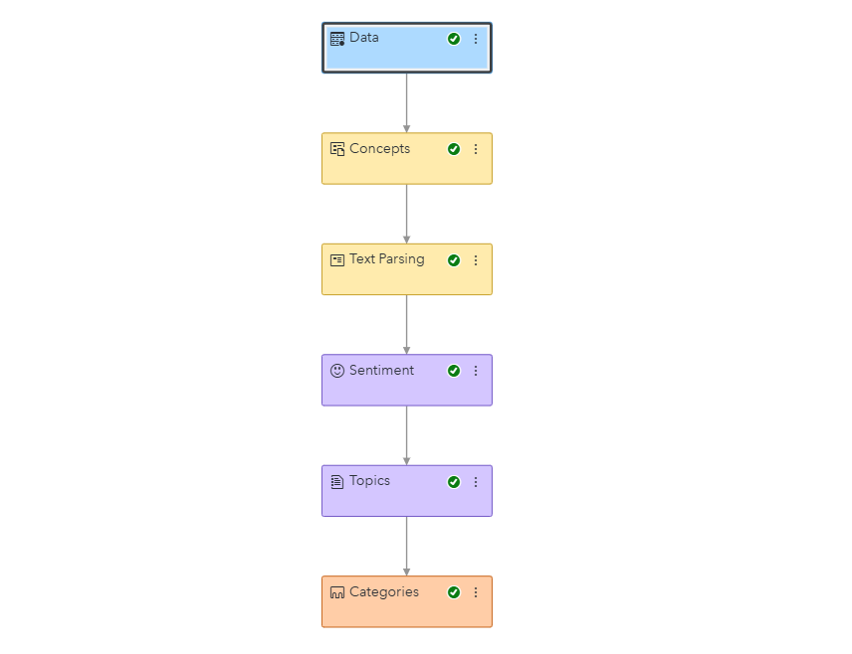

**Image 17**

The **Concepts Node** in SAS Viya was utilized to extract and classify both predefined and custom concepts from the tweets dataset, enabling structured analysis of unstructured text.

**Key Highlights:**

1. **Predefined Concepts**:
   * Extracted entities like dates (nlpDate), locations (nlpPlace), times (nlpTime), and organizations (nlpOrganization).
   * These categories provide critical details about accident locations, times, and affected organizations.
2. **Custom Concepts**:
   * Concepts such as *Cities*, *Time*, *Congestion*, *Direction*, *Highway*, *Junctions*, *Road*, and *Lanes* were created to capture terms specific to cities (e.g., "Woking," "Guildford") and road features (e.g., "lane 1").
   * These concepts enhance domain-specific insights relevant to road accidents.
3. **Matched Data**:
   * Of the 598 tweets analyzed, 274 matched the *Cities* concept, frequently mentioning cities involved in accidents.
   * Highlighted matches provide context on the usage and relevance of specific concepts in the dataset.

This process was essential for identifying structured patterns and extracting meaningful insights from the text data.

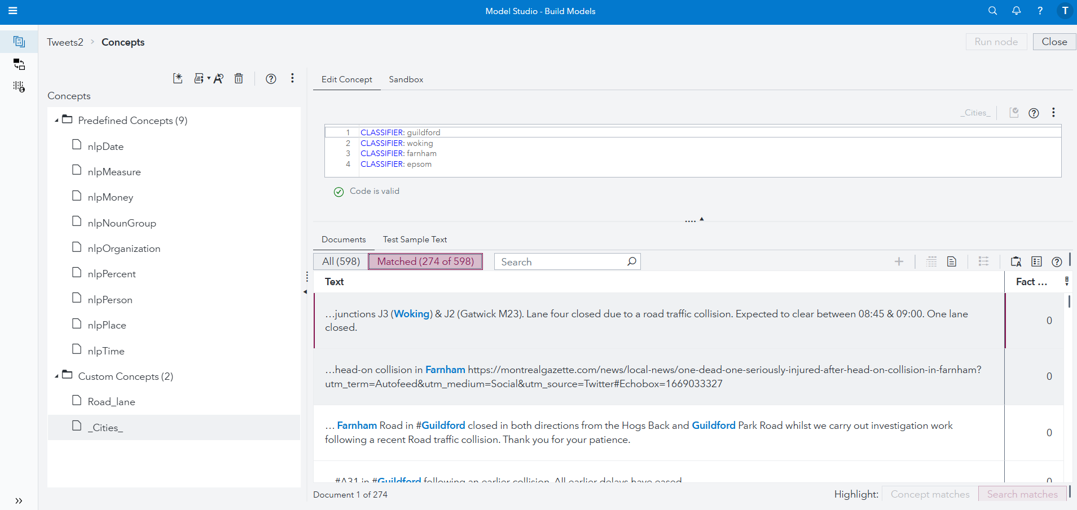

**Image 18**

**Text Preprocessing**

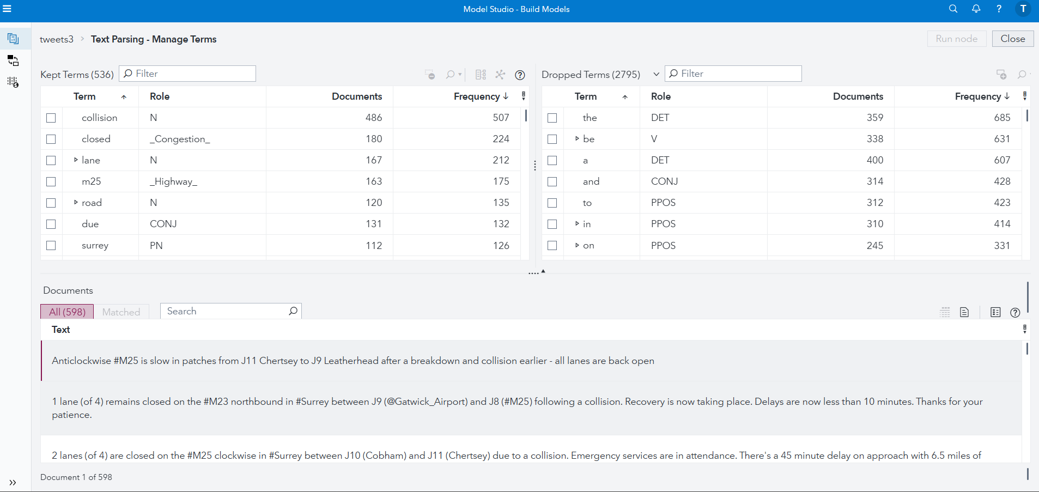

**Image 19**

Text preprocessing was conducted using the **Text Parsing** node in SAS Viya to improve dataset quality and consistency. Key steps included:

1. **Removing Special Characters and Punctuation**: Eliminated symbols and noise, retaining meaningful text content.
2. **Tokenization**: Split text into individual words or phrases, enabling word-level analysis and facilitating frequency and sentiment analysis.
3. **Handling Start and Stop Words**: Removed common words (e.g., "and," "the") to reduce redundancy and focus on significant terms.

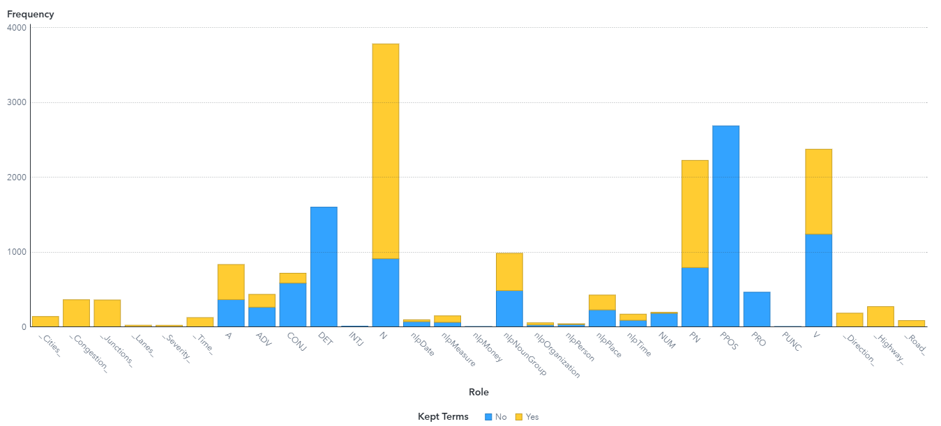

**Image 20**

The Text Parsing node streamlined preprocessing, creating a clean and standardized dataset for analysis. This automated approach ensured efficiency and consistency, providing a solid foundation for advanced text analytics.

**Exploratory Analysis**

Exploratory text analysis uncovered patterns and key themes in the dataset using word clouds for keywords, concepts, and text frequency. Key findings include:

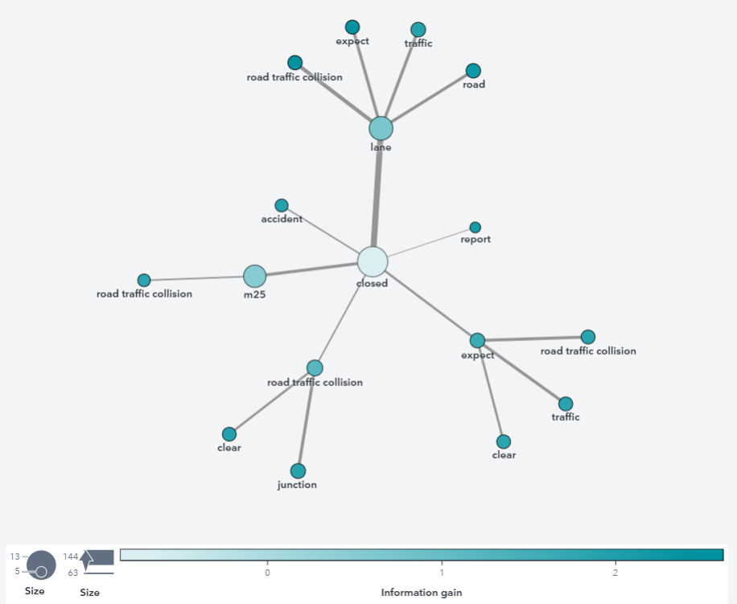

**Image 21**

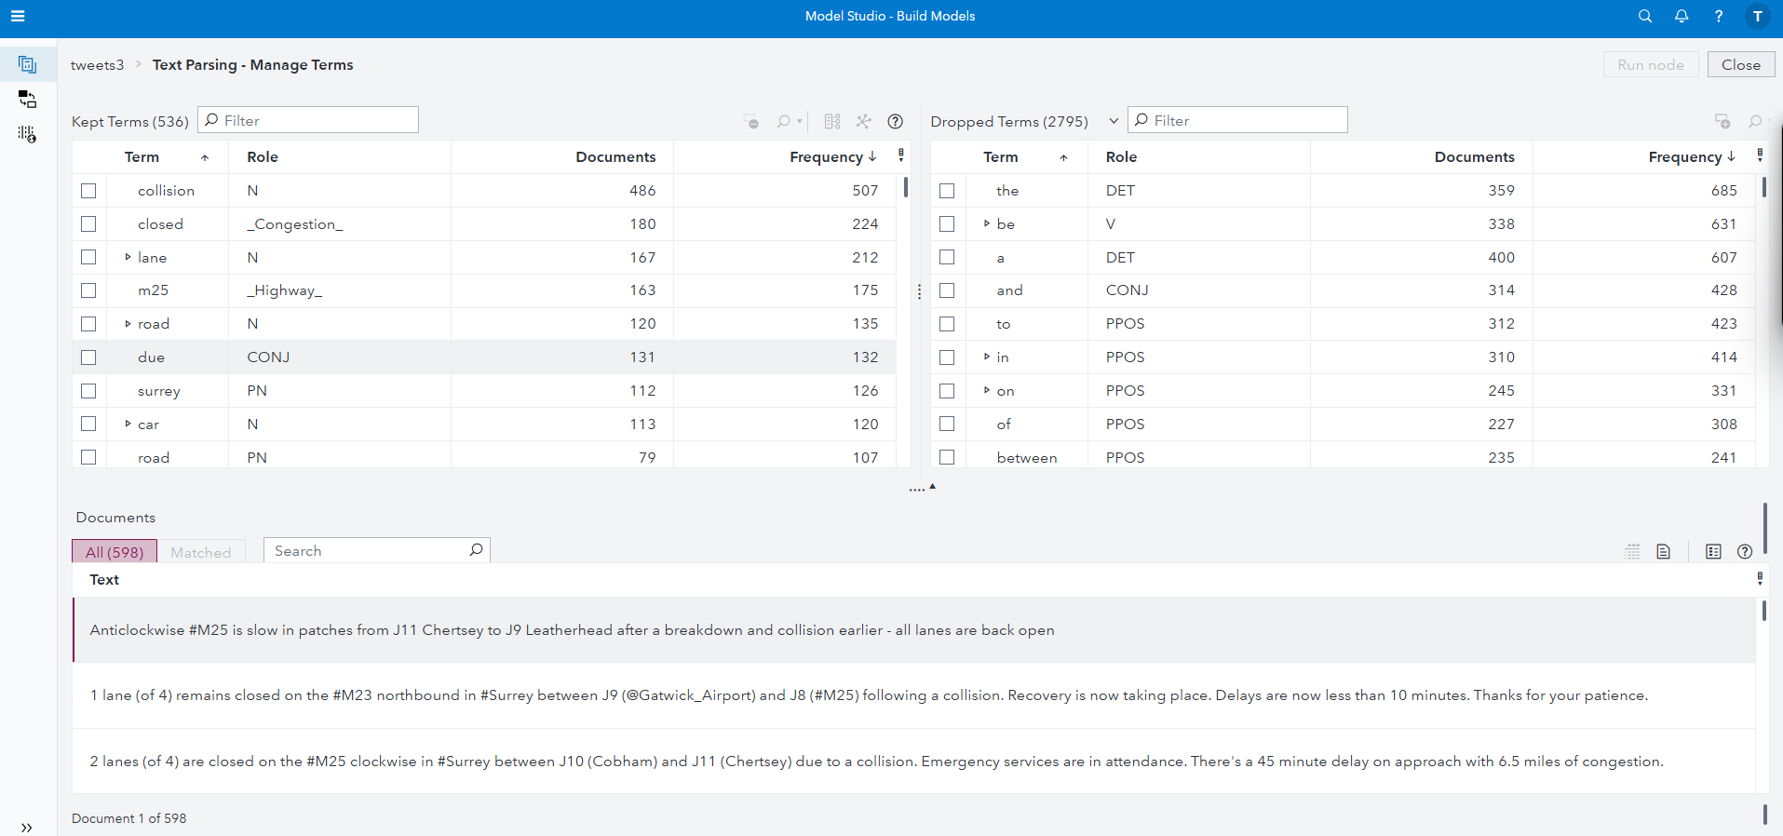

**Image 22**

* **Keyword Analysis**: Frequent terms like "Guildford," "closed," "M25," "Woking," and "serious" emphasize road closures, traffic disruptions, and accident severity in Surrey.

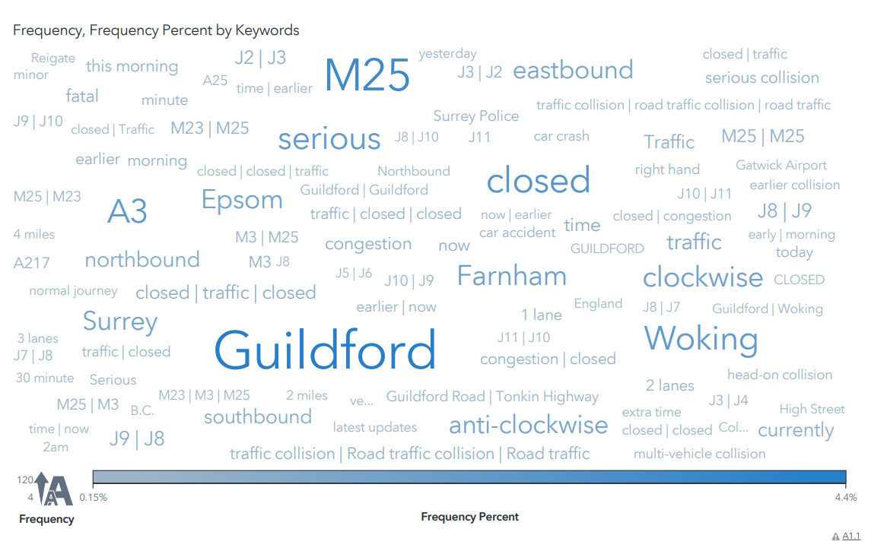

**Image 23**

* **Concept Analysis**: Common concepts such as "Congestion," "Direction," "Highway," and "Severity" highlight traffic impact and accident outcomes.

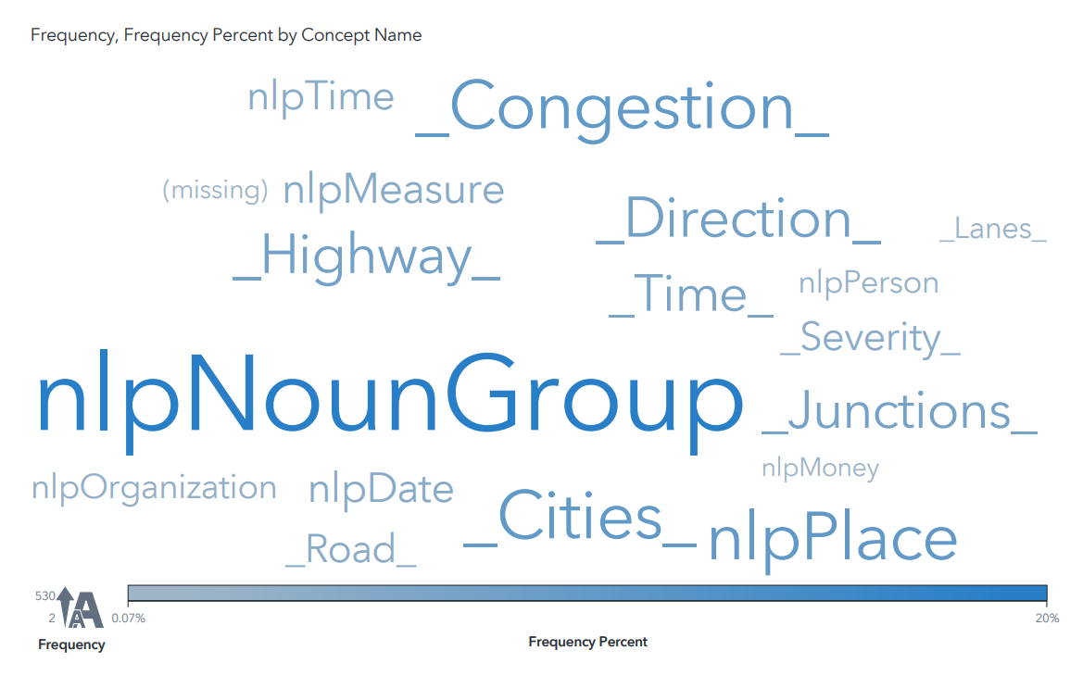

**Image 24**

* **Text Patterns**: Recurring phrases focus on road closures, serious collisions, and traffic updates, particularly on major highways like the M25 and A3.

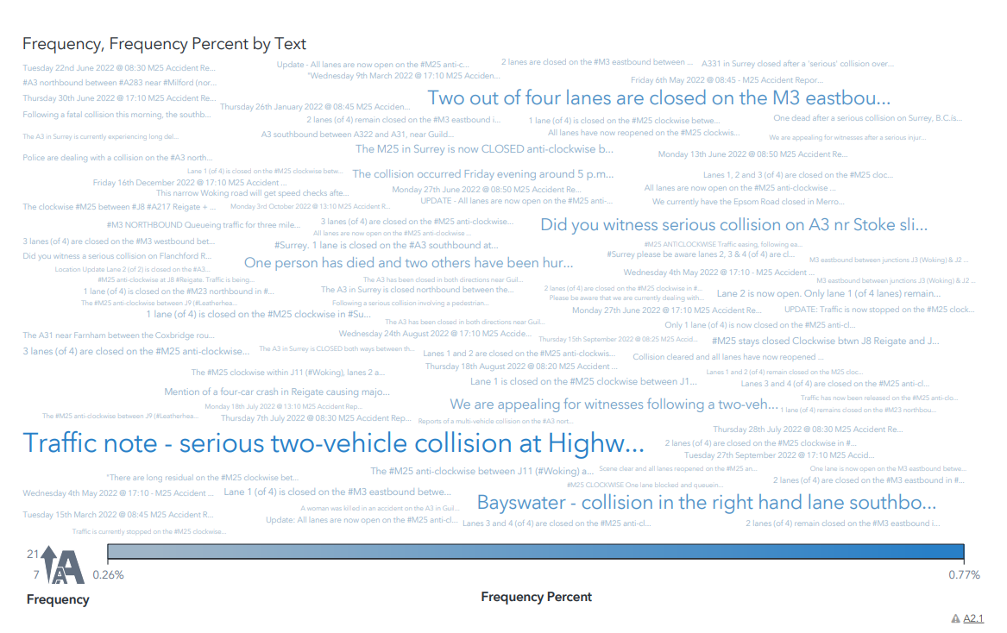

**Image 25**

**Insights**

The analysis reveals a focus on high-traffic areas, accident severity, and traffic disruptions, providing a foundation for further sentiment analysis and topic modeling.

**Sentiment Analysis**

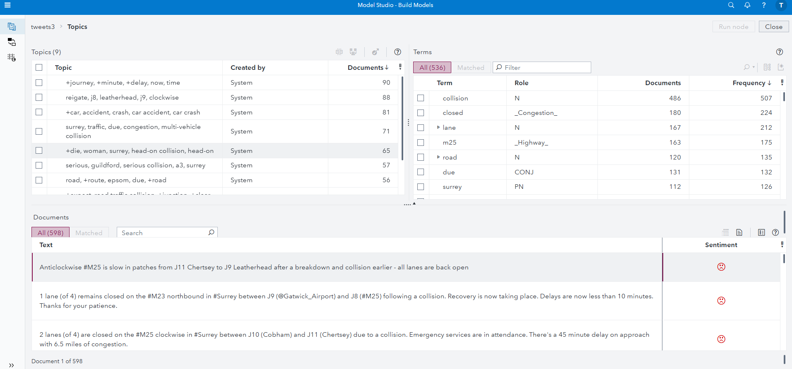

**Image 26**

Sentiment analysis was performed on the tweets to understand the overall sentiment (positive, negative, or neutral) regarding road accidents and traffic in Surrey. The analysis results are summarized below:

**1. Sentiment Distribution**

* The majority of tweets exhibit **negative sentiment**, reflecting public concern, frustration, and the serious nature of traffic accidents and road closures.
* A smaller proportion of tweets convey **neutral sentiment**, often factual updates on traffic conditions and closures.
* Few tweets show **positive sentiment**, typically related to safety initiatives or expressions of gratitude.

**2. Topic-Specific Sentiment**

The sentiment was analyzed across key topics identified in the dataset:

* **Accidents and Collisions**: Predominantly negative due to the serious and often fatal nature of incidents.
* **Traffic and Congestion**: Negative sentiment driven by delays and disruptions.

**Visual Representation**

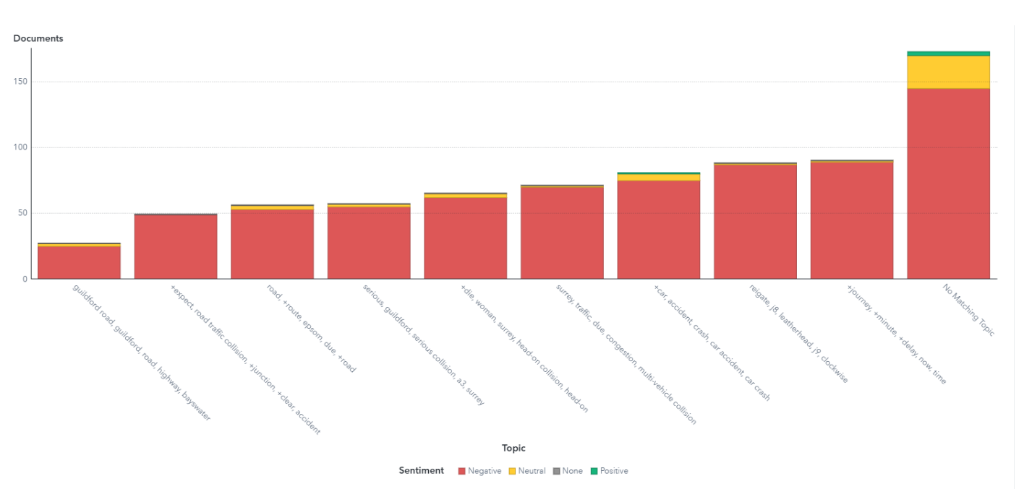

**Image 27**

The bar chart categorizes sentiment for various topics, illustrating that negative sentiment dominates across most topics. The chart emphasizes areas of public concern, such as severe accidents and significant traffic disruptions.

**Insights**

* The overwhelming negativity highlights public frustration and concern surrounding accidents and traffic conditions.
* Positive sentiment, while rare, provides insight into appreciation for safety measures or community support.

**Conclusion**

The sentiment analysis reflects public perception of road conditions and traffic incidents in Surrey, with a clear emphasis on negative sentiment. These insights can inform authorities about areas of public dissatisfaction and help shape strategies to improve communication and road safety measures.

**Text Analysis Report**

**Key Insights and Findings**

1. **Public Concern**: Negative sentiment dominates the dataset, reflecting public dissatisfaction with road conditions, accidents, and congestion in Surrey.
2. **Focus on High-Traffic Areas**: Locations like Guildford and the M25 are frequently mentioned, highlighting their importance in traffic and accident discussions.
3. **Accident Severity**: Discussions emphasize serious and fatal accidents, underlining the need for enhanced road safety measures.
4. **Traffic and Congestion**: Key themes include traffic delays, lane closures, and multi-vehicle collisions, demonstrating the widespread impact of these issues.
5. **Community Engagement**: Positive sentiment, though rare, highlights appreciation for safety initiatives and public responses to accidents.

**Conclusion**

The analysis underscores public frustration with accidents and traffic disruptions while emphasizing the need for better communication, safety measures, and infrastructure improvements in high-traffic areas. These findings provide actionable insights for addressing public concerns and improving road safety.

**Task 4** – Decision-Maker's Summary and Recommendations **[20 marks]**

Maximum 2 pages including tables, figures (do not use appendix for this task)

This report analyses road accidents in Surrey, UK, during 2021, providing key insights and actionable recommendations to improve road safety and reduce accident severity. The findings are based on a detailed dataset and data-driven analysis, with clear strategies outlined for decision-makers.

**Key Findings**

**1. Accident Patterns**

* **Severity**: Most accidents are slight, with serious and fatal accidents representing a smaller share. Fatal accidents, while rare, require targeted focus due to their severity.
* **Timing**: Accidents are most frequent during rush hours, correlating with high traffic volumes. Off-peak hours see significantly lower accident frequencies.

**2. High-Risk Locations**

* **Non-Junction Areas**: Account for the highest number of accidents, predominantly slight.
* **Single Carriageways**: Major contributors to accidents, highlighting the need for safety interventions.
* **Hotspot Areas**: Certain local authority districts experience a higher density of accidents, necessitating focused action.

**3. Contributing Factors**

* **Speed**: Most accidents occur in 30 mph zones, but higher-speed areas are associated with greater severity.
* **Weather Conditions**: Poor weather and road surface conditions increase accident risks, emphasizing the importance of infrastructure maintenance.

**Recommendations**

**1. Time-Based Interventions**

* Deploy traffic enforcement during rush hours to manage congestion and reduce accidents.
* Implement dynamic traffic management systems for real-time signal adjustments and congestion mitigation.

**2. Targeted Infrastructure Improvements**

* Enhance safety at high-risk junctions with improved signage, traffic lights, and roundabouts.
* Address accident hotspots with speed cameras, reflective markers, and better lighting.

**3. Speed Control**

* Strengthen speed enforcement in high-risk zones, especially urban areas.
* Introduce variable speed limits during adverse weather or peak traffic periods.

**4. Public Awareness Campaigns**

* Educate drivers about accident risks during peak hours and in specific road conditions.
* Promote safety campaigns focusing on speeding, distracted driving, and adverse weather.

**5. Data-Driven Safety Measures**

* Use predictive models to monitor risk patterns and deploy resources pre-emptively.
* Collaborate with local authorities to invest in accident-prone areas and improve road conditions.

**Conclusion**

By addressing the identified risk factors and implementing the recommended strategies, Surrey can significantly enhance road safety and reduce accident severity. The insights derived from this analysis provide a roadmap for targeted interventions, effective resource allocation, and long-term safety improvements.

Visualizations and data summaries are included to support these findings, ensuring clarity and actionable insights for decision-makers.

**Image 28**

**Image 29**

**Image 30**

**Appendix**

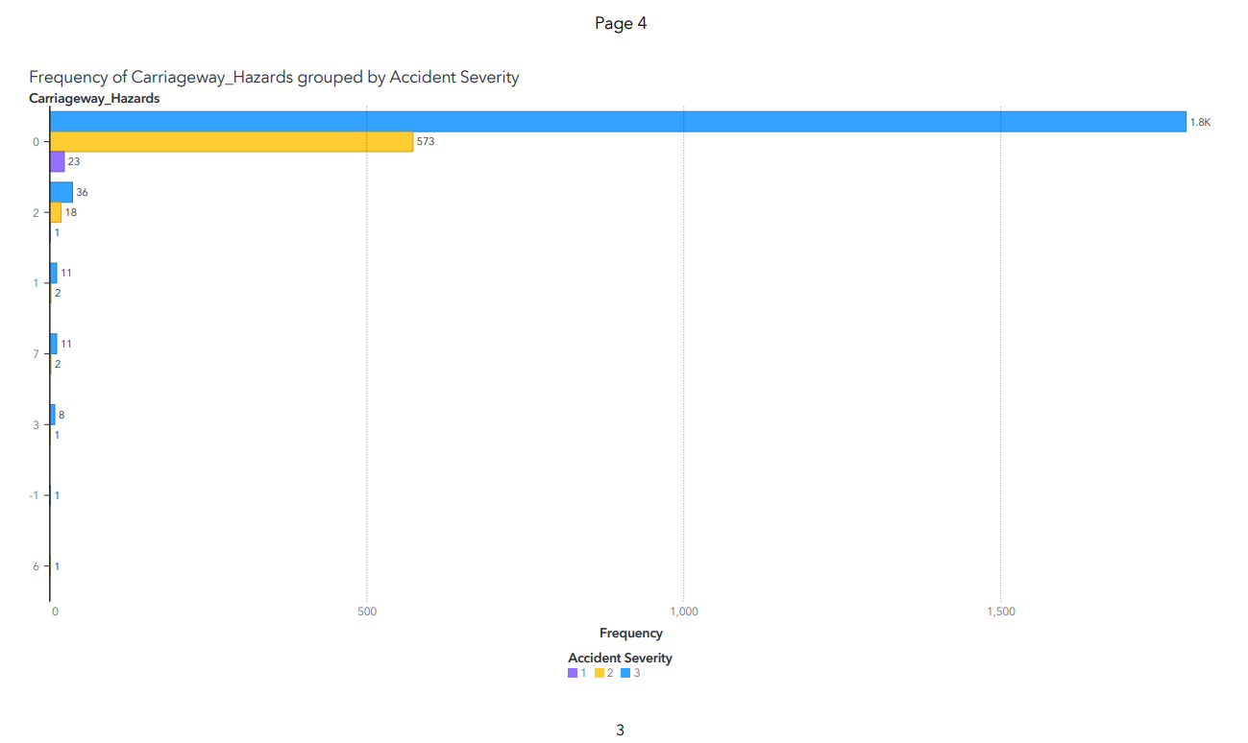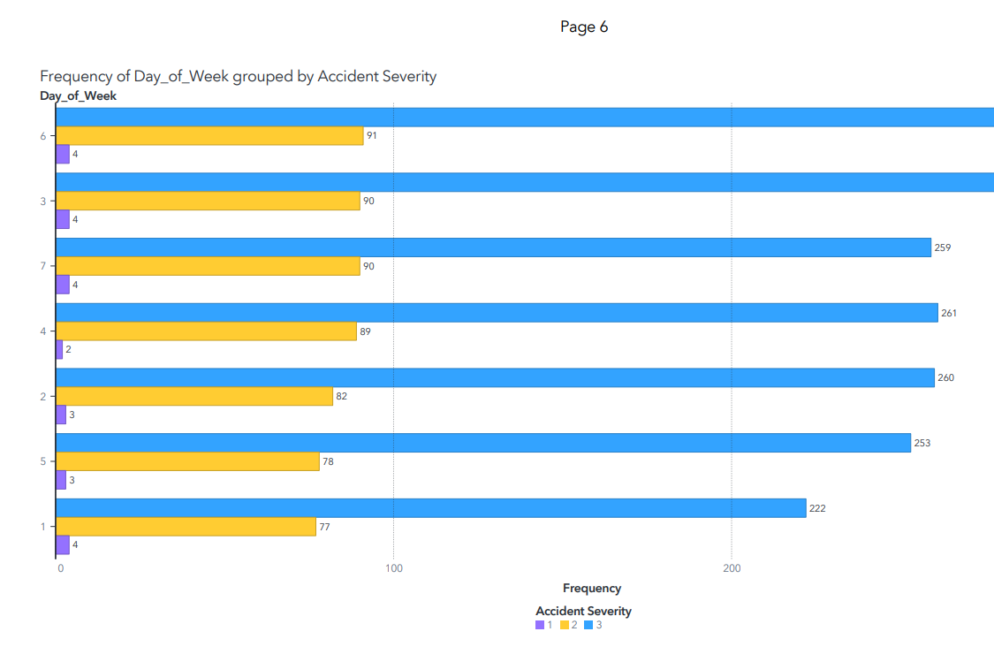

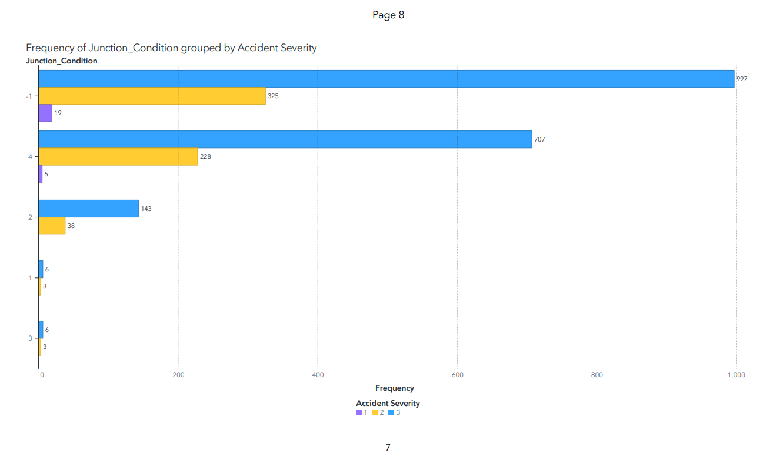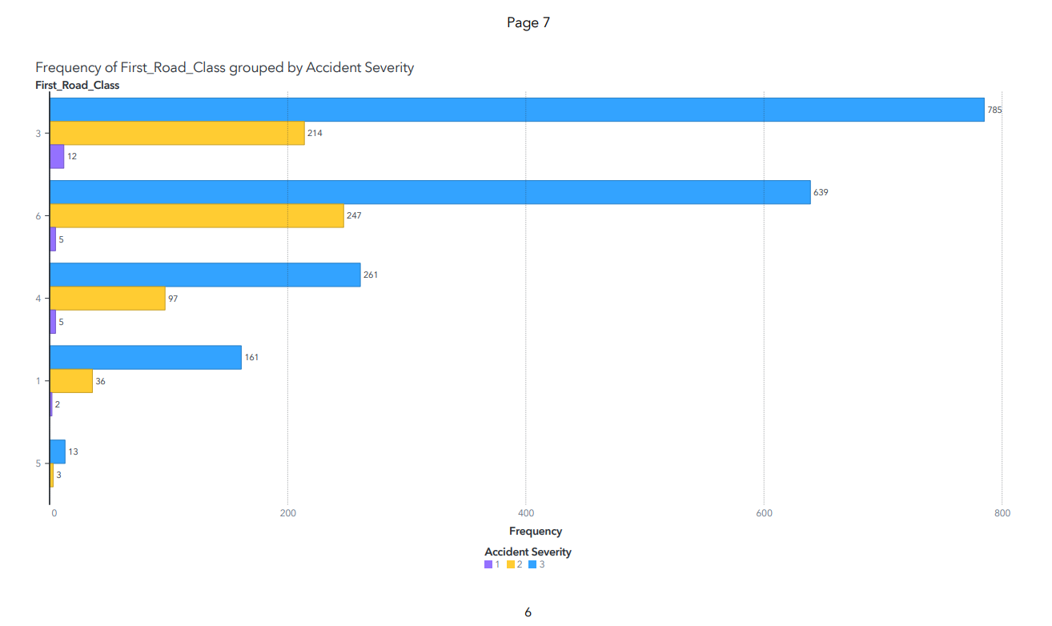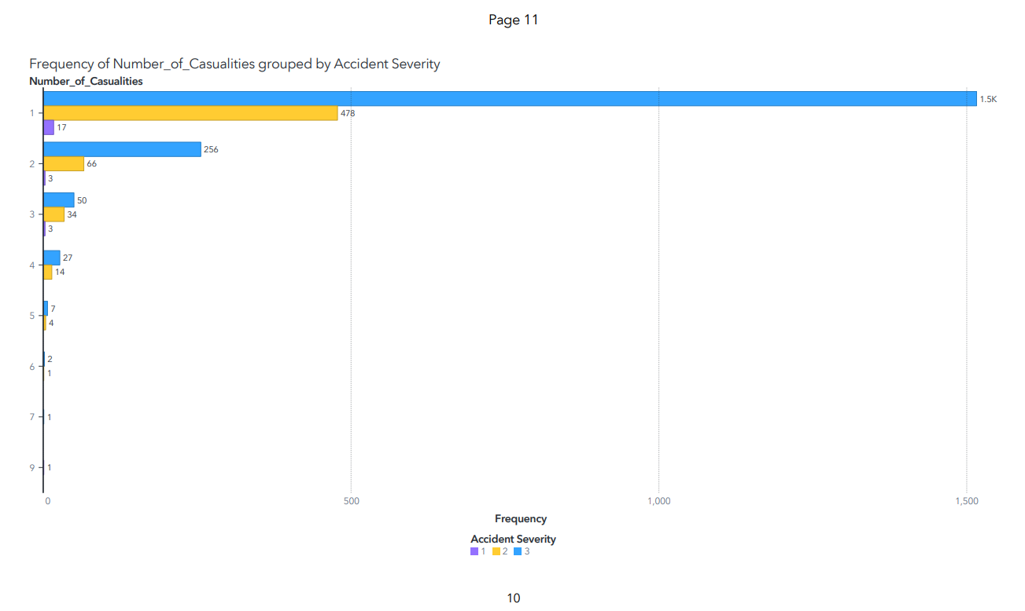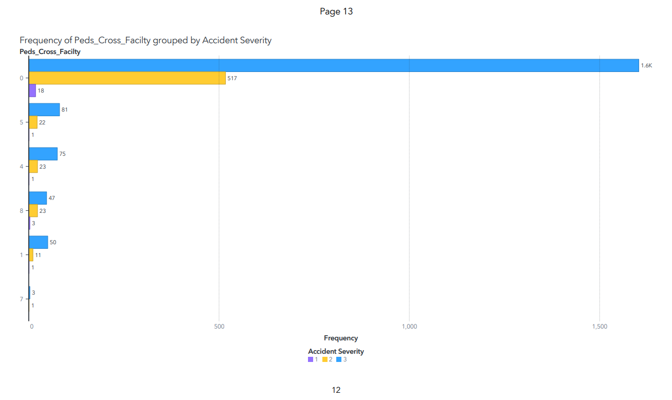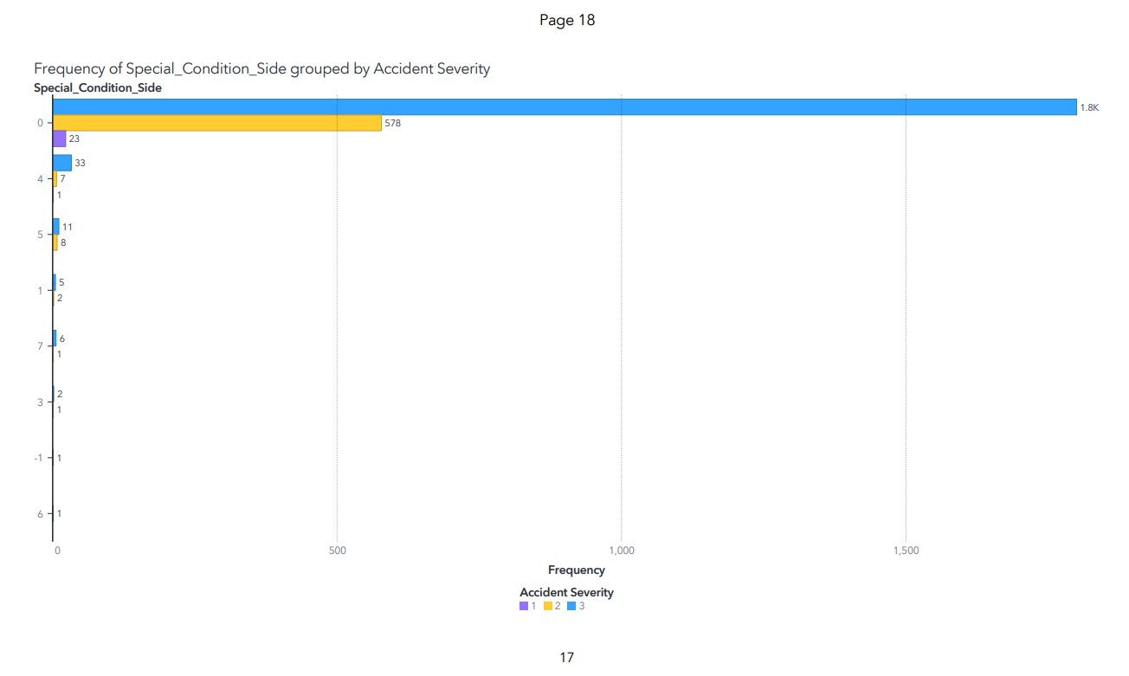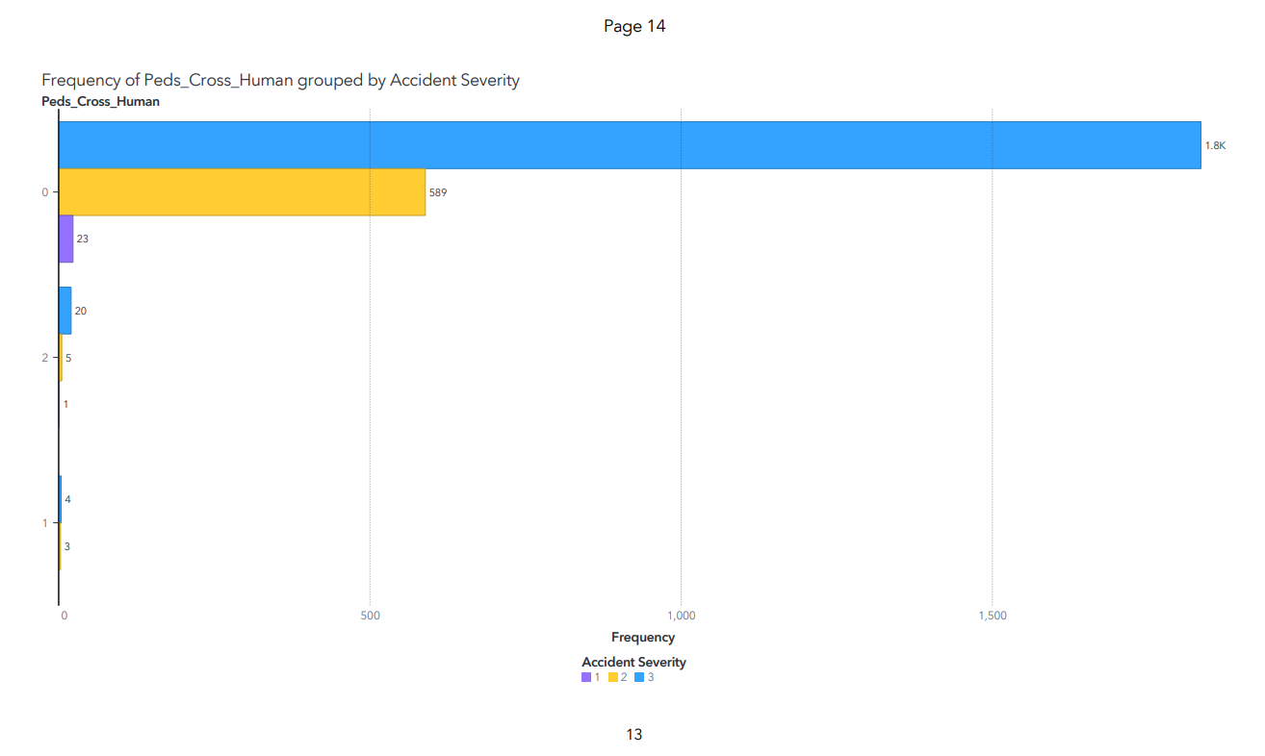

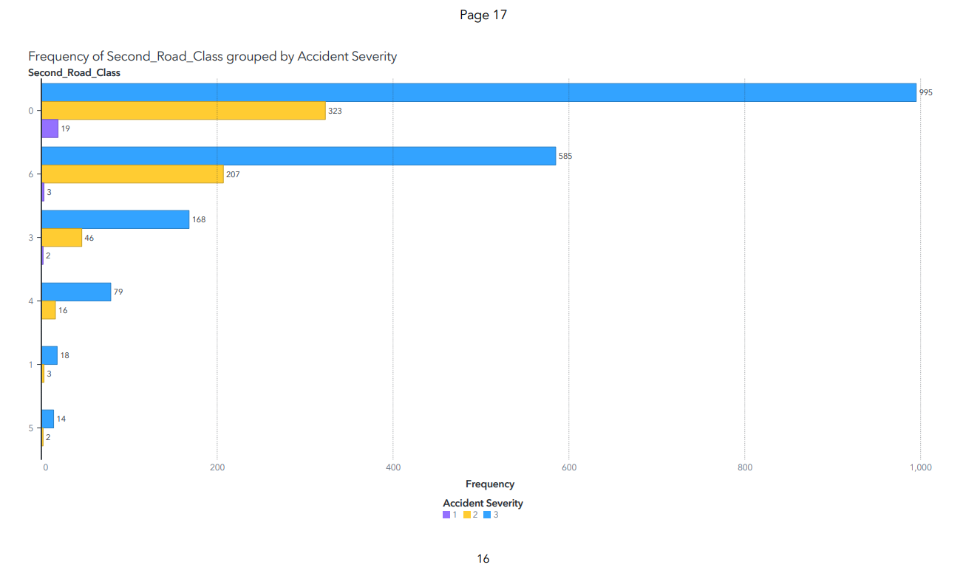

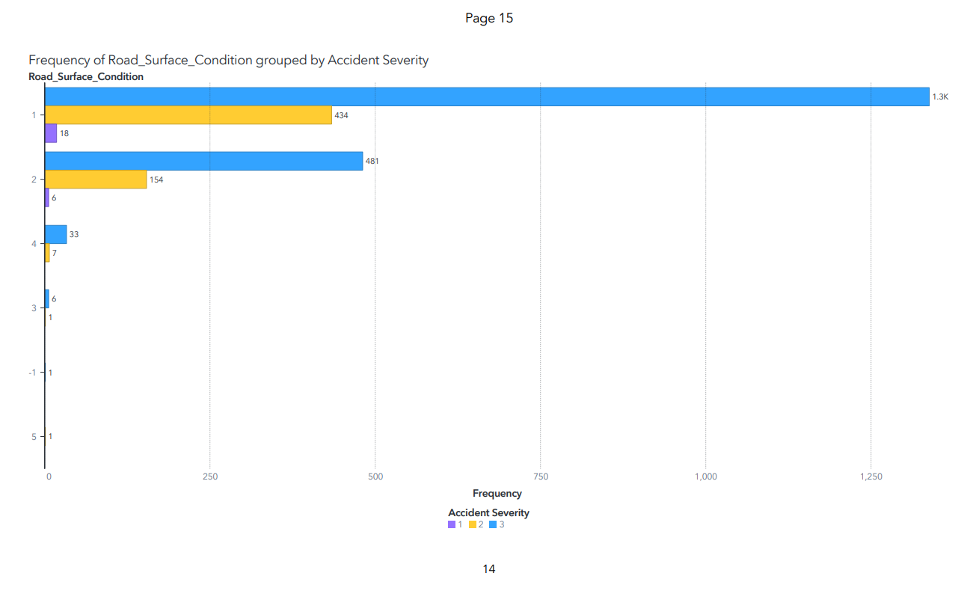

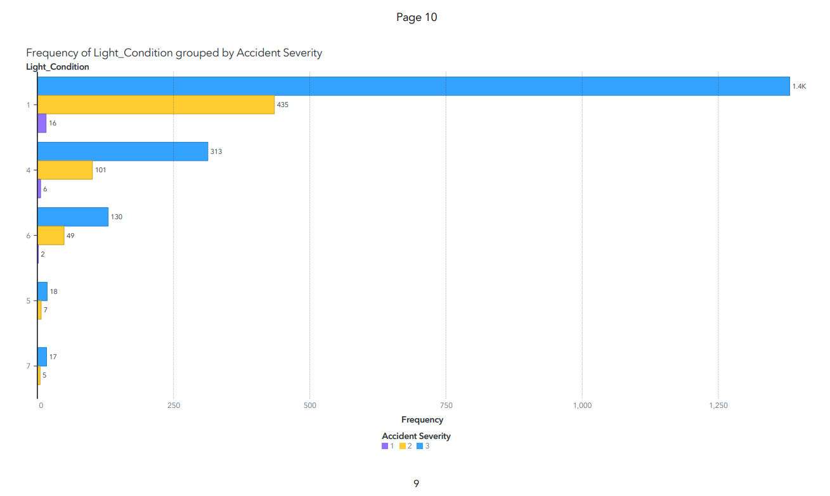

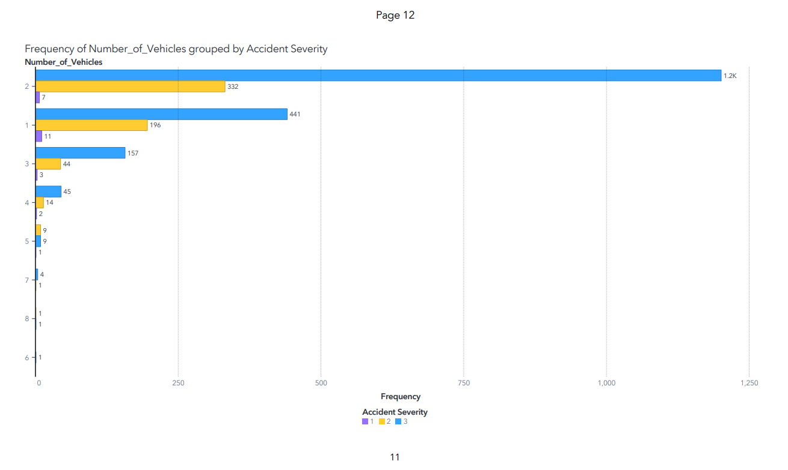

**General –** Layout, storytelling, professionalism, and Harvard Referencing will be assessed.[ **10 marks]**

Task 1, 2 and 3 (Technical report): Maximum 3000 words excluding tables, figures and appendices

Task 4 (managerial report): Maximum 2 pages including tables, figures (no appendix for this task)

**What To Submit?**

1. One file (Word or PDF) containing two parts: a technical report for tasks 1, 2, and 3 (maximum of 3000 words, excluding the title page, tables, figures, and appendix) and a managerial report for Task 4 (maximum of 2 pages, including tables, figures, no appendix for this task)
2. A PDF file of your saved SAS project.